**QUIZ RESULTS**

**MODULE2: K NEAREST NEIGHBORS**

|  |  |  |  |  |
| --- | --- | --- | --- | --- |
| **No.** | **Quiz title** | **Completion Status** | **Score** | **Coursera link** |
| 1 | Module2_K Nearest Neighbors | Completed | 100% | [Quiz 1](https://www.coursera.org/learn/supervised-machine-learning-classification/assignment-submission/YNioU/k-nearest-neighbors/view-feedback) |
| 2 | Module2_K Nearest Neighbors Labs | Completed | 100% | [Quiz 2](https://www.coursera.org/learn/supervised-machine-learning-classification/assignment-submission/mEvbI/k-nearest-neighbors-labs/view-feedback) |
| 3 | Module2_KNN | Completed | 100% | [Quiz 3](https://www.coursera.org/learn/supervised-machine-learning-classification/assignment-submission/wDcSA/module-2-graded-quiz-knn/view-feedback) |

# Module2_K Nearest Neighbors

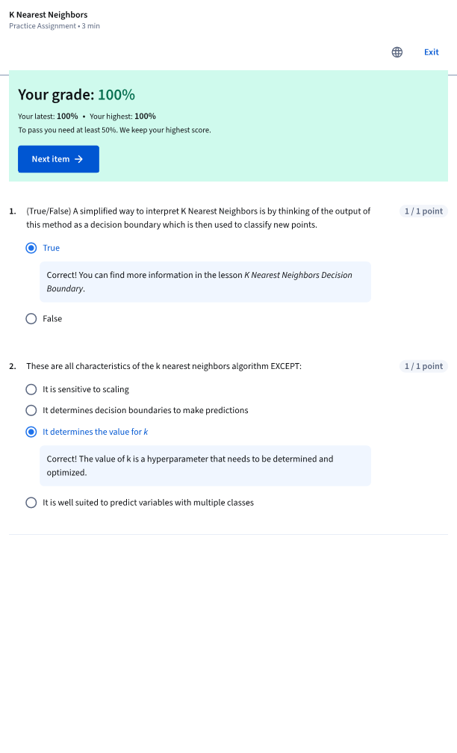

# Module2_K Nearest Neighbors Labs

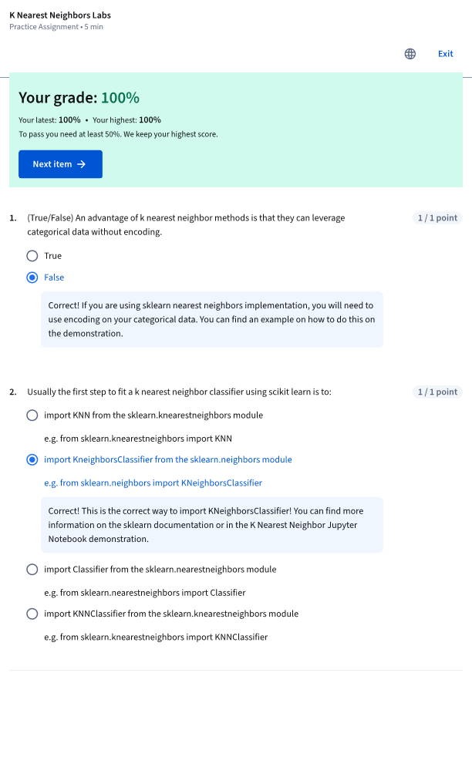

# Module2_KNN

